

**Fundamentals of Programming**

**Home task, lab manual#4**

**Name: Muhammad Amad Naeem**

**Id: 467469**

**Section: ME-15 Section-B**

**Professor: Affan**

**Task#1:**

**#include<iostream>**

**using namespace std;**

**int main(){**

**int i,a;**

**for(i=1;i<=150;i++)**

**{a=i;**

**if(a%10!=0){**

**cout<<a<<endl;}**

**}**

**return 0;}**

**Output:** 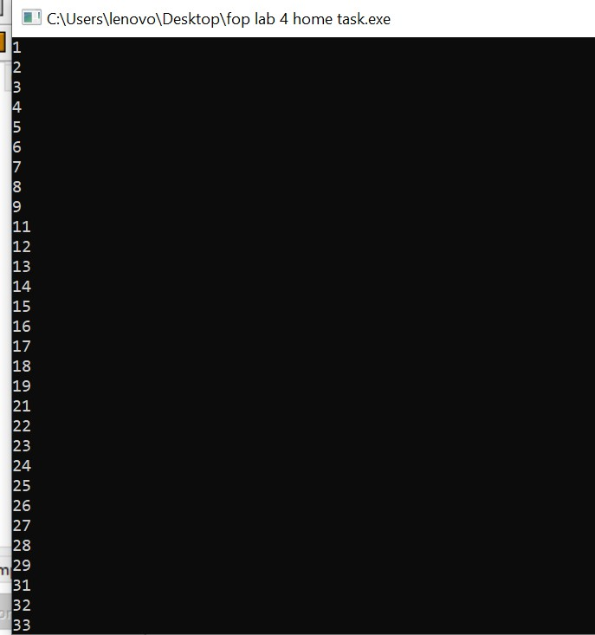

**Task#2:**

**#include<iostream>**

**using namespace std;**

**int main(){**

**int a,i,b=0,c;**

**cout<<"input a number"<<endl<<"num: ";**

**cin>>a;**

**while(a>0)**

**{c=a%10;**

**b=c+b;**

**a=a/10;**

**}**

**cout<<"sum of digits = "<<b;**

**return 0;}**

**Output:**

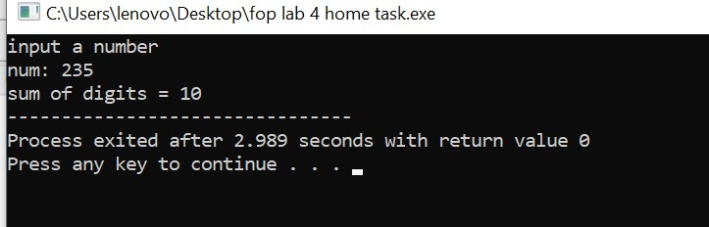

**Task#3:**

**#include<iostream>**

**using namespace std;**

**int main(){**

**int a,i,x=0,c;**

**cout<<"enter a number."<<endl<<"num: ";**

**cin>>a;**

**for(i=1;i<=a;i++){**

**c=a%i;**

**if(c==0){**

**x++;**

**}**

**}**

**if(x==2){**

**cout<<a<<" is a prime number";**

**}**

**else**

**{cout<<a<<" is not a prime number";**

**}**

**return 0;}**

**Output:**

